UMKC HACKATHON



**Team: RooCoders**

Sree Rama Raju Pericharla

Akhilesh Gattu

Nagi Reddy Sollapuram

Santosh Kumar



Buying a product without checking any review is like expecting a stranger to be loyal to us. In Present days the online shopping is the buzz of the day with hundreds of Products growing each day. This throws the customers with the challenge of dealing with more number of products and hundreds of reviews for those products. So it is very important to know the proper and exact review of any product before purchasing it. So our application “Review Point” deals with avoiding the overhead of handling of multiple Reviews and lets customers to enjoy all their favorite product with the confidence on it.

**Why Review Point?**

With exponential increase of products and their purchases the reviews and ratings of those products multiplied day by day. This scenario leads the customer job of getting the right review will be a tiring job and very difficult task to know the proper review on their decision of buying that product. So our application Review Point will be a solution for this. Review Point application will analyze all the reviews and rating of those product and gives Review Point’s rating & suggests the customer about his idea of purchasing that product.



1. **ARCHITECURTE DIAGRAM**

Request to dB

Server

Storing data in database

Elastic Search

Review data

Response from DB

query

result

Web application

|  |
| --- |
| TECHNOLOGIES USED USED |
| Python |
| Angular JS, JavaScript |
| HTML 5.0, CSS, Bootsrap |
| Elastic Search database |

The above table shows the list of technologies used .

**Screenshots of the application:**

**Home Page:**

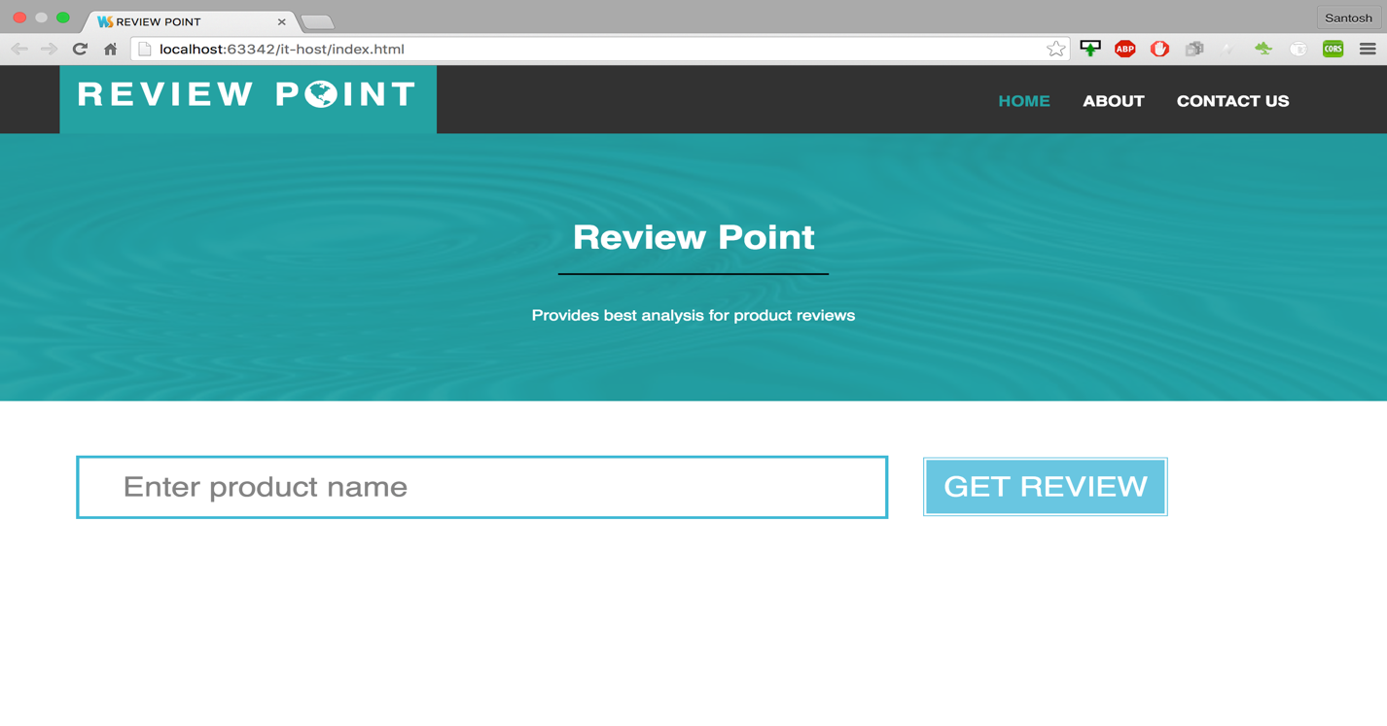

**Reviews for ipod speaker :**

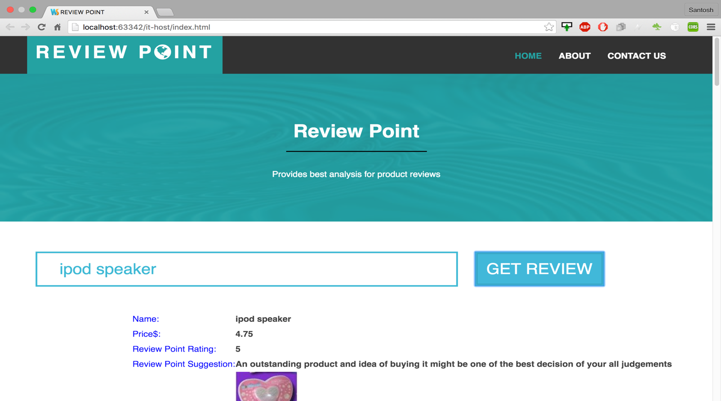

**Displaying various product with name “ipod speakers” :**

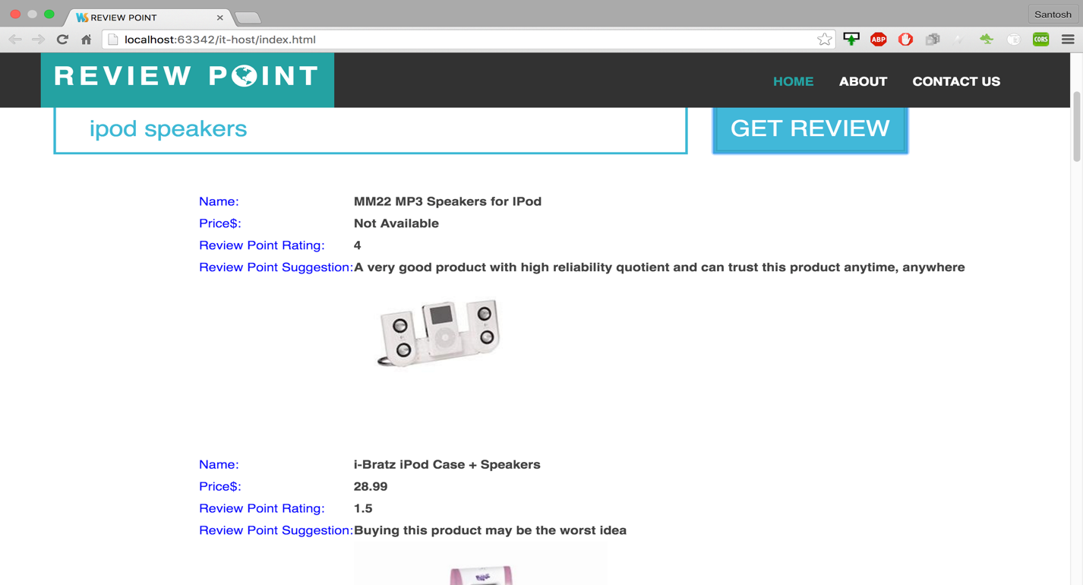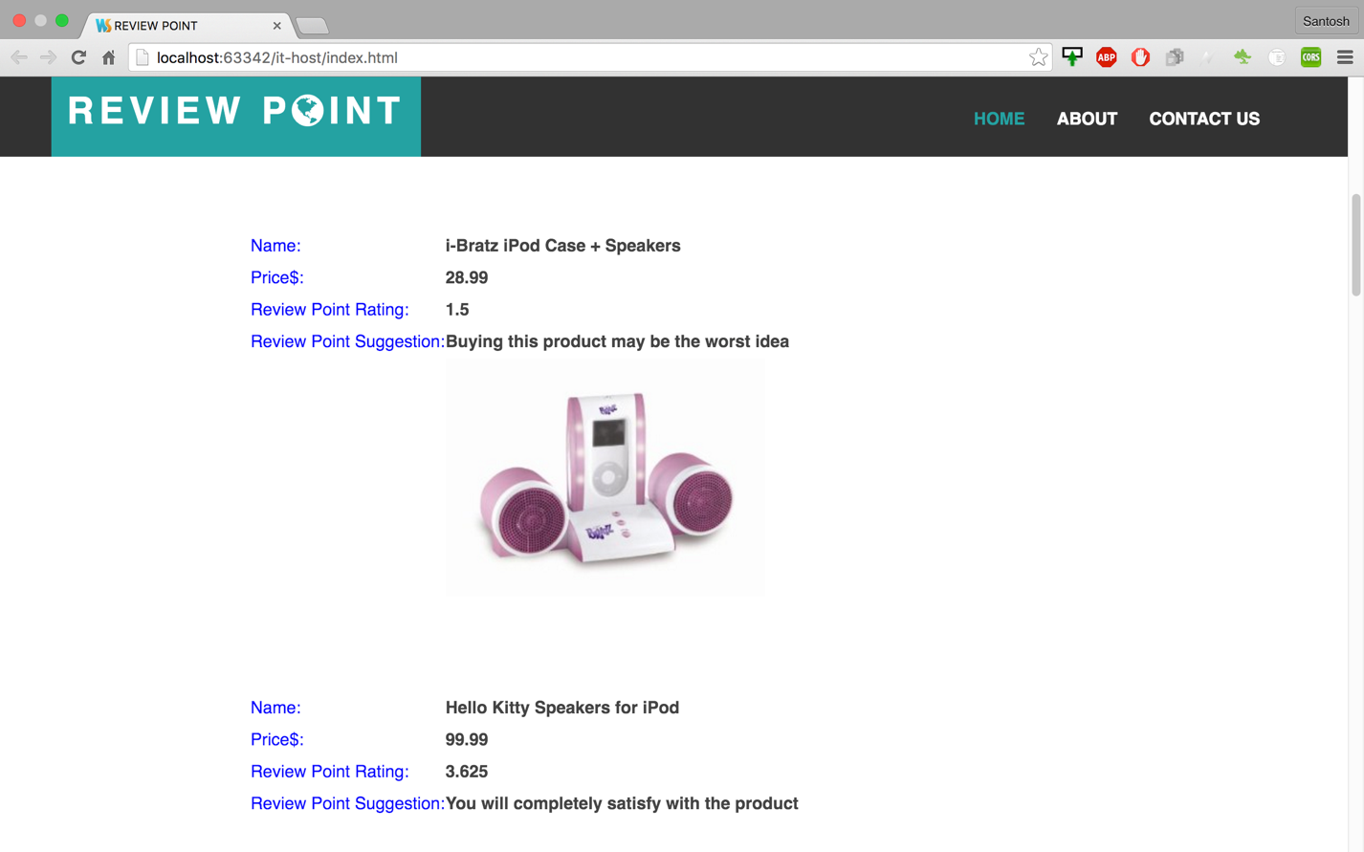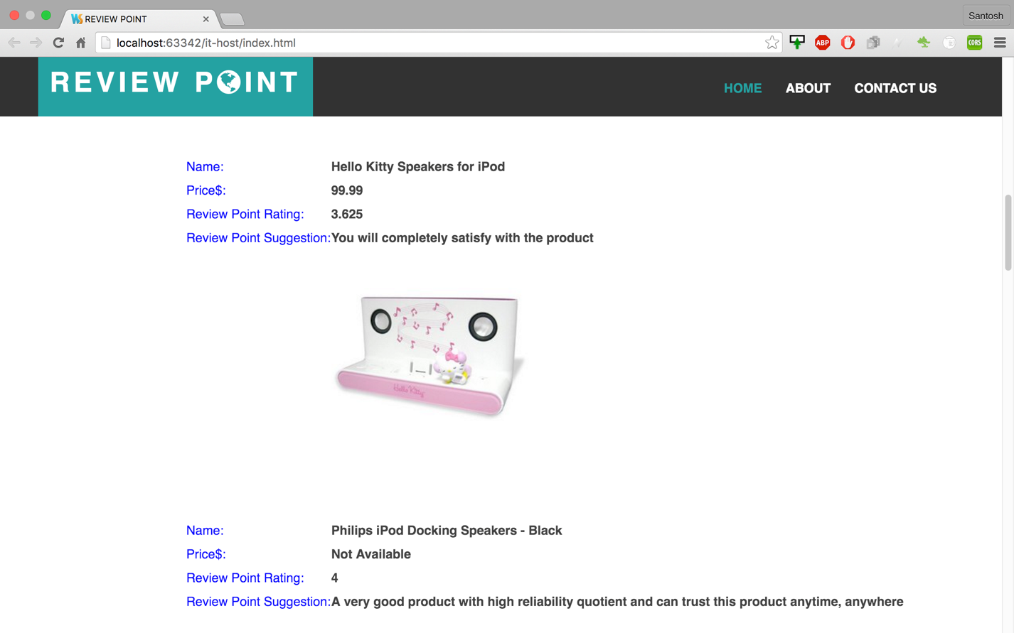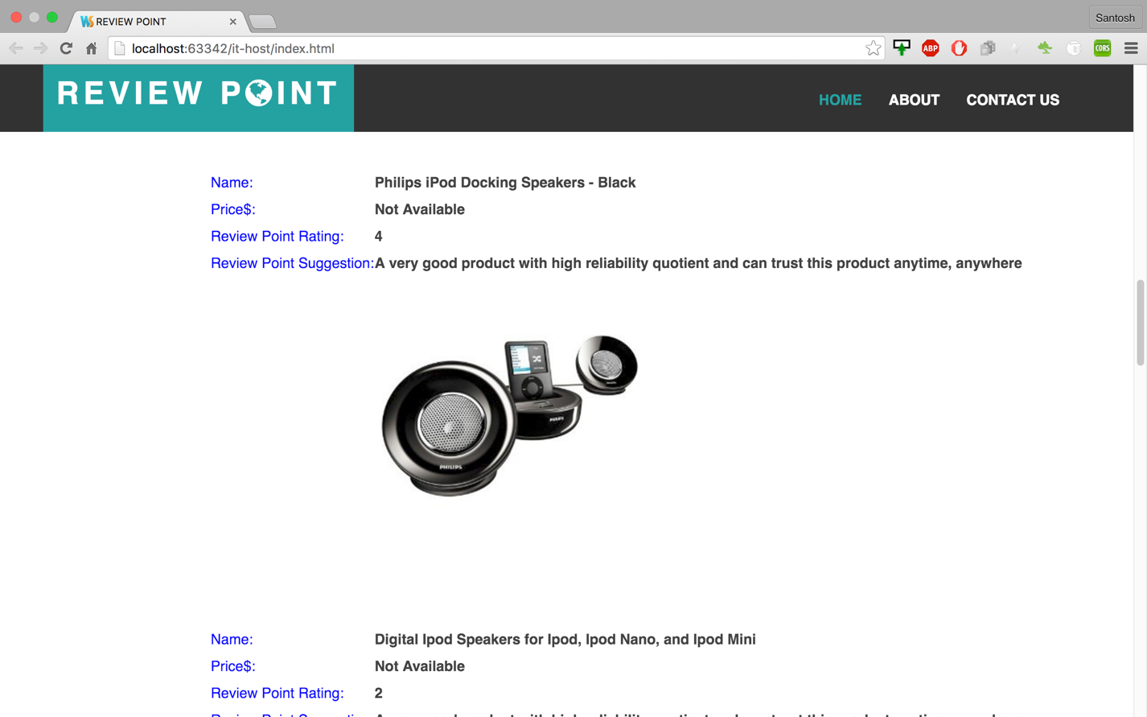

**Overview of our application:**

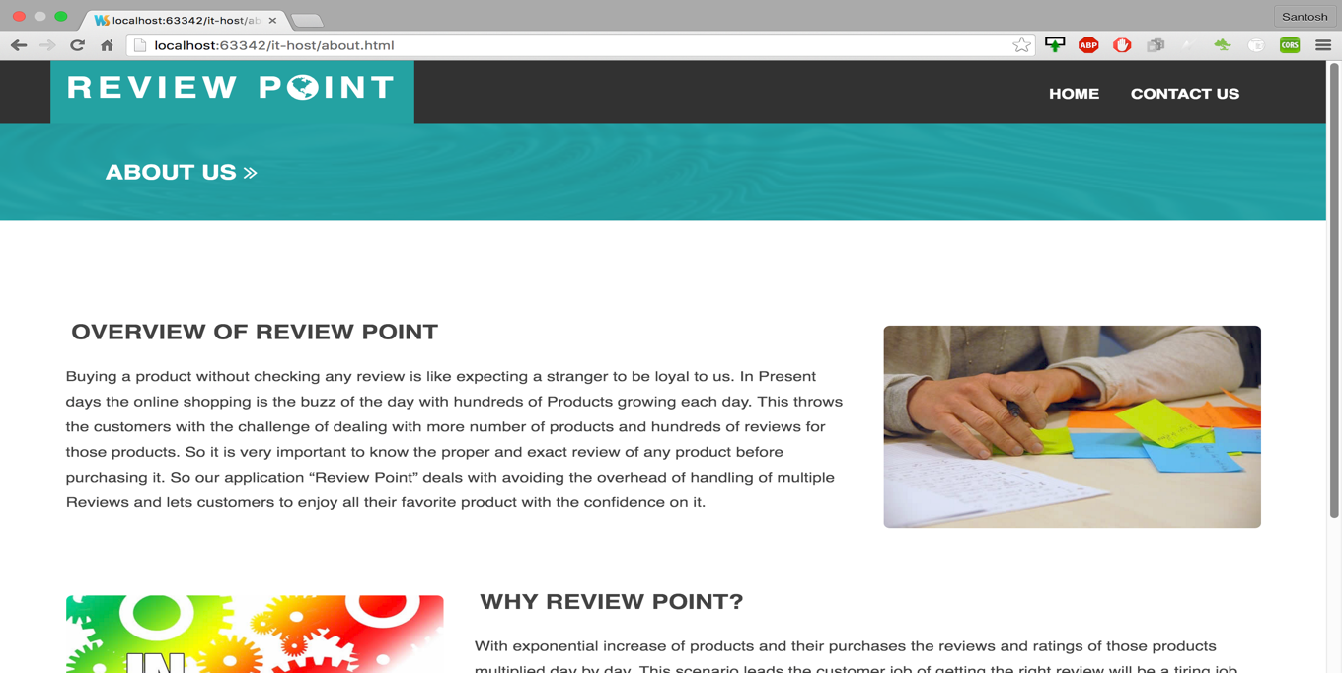

**Why analyzation of reviews is required?**

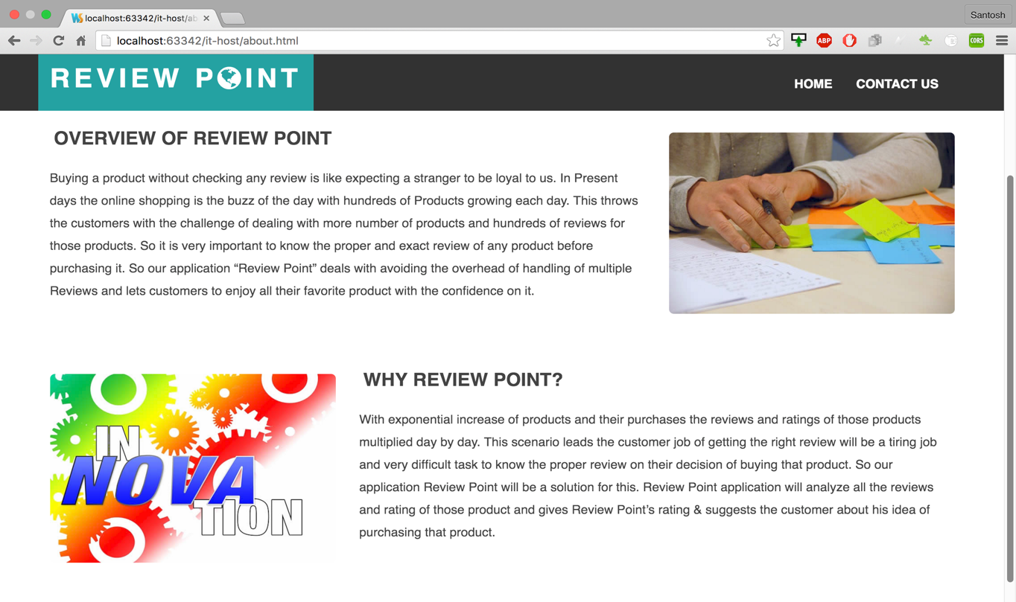

**Contact Us page:**

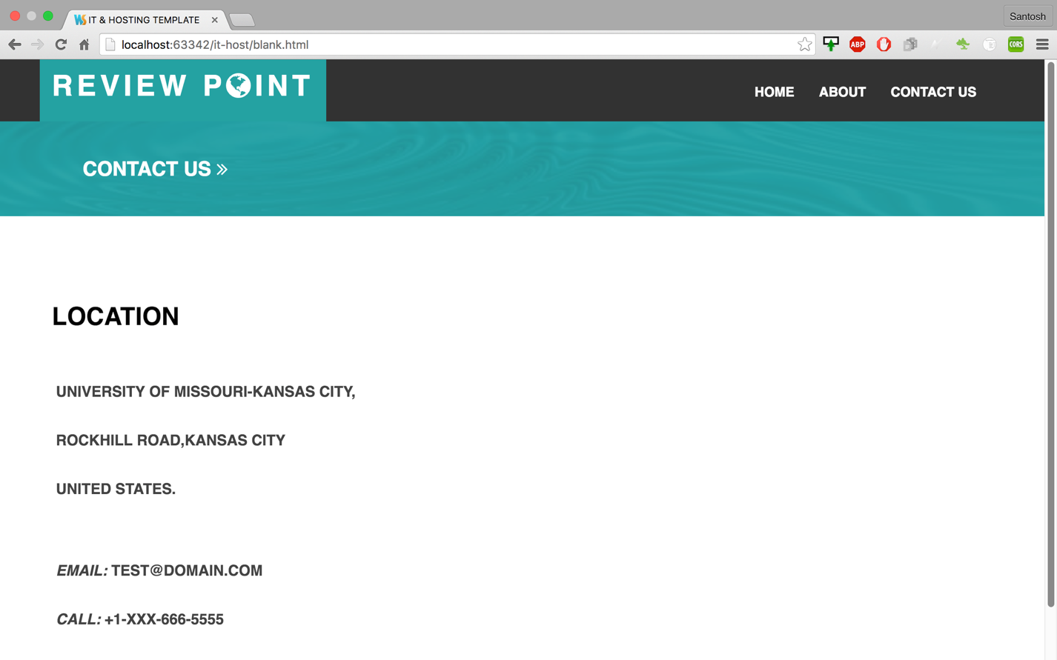

**Product reviews for “Nikon” :**

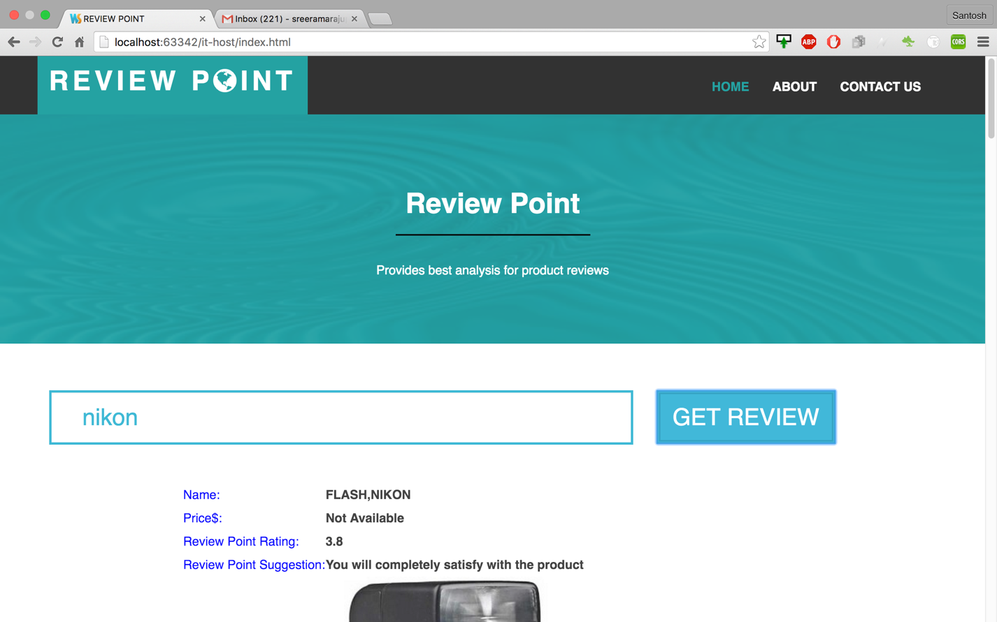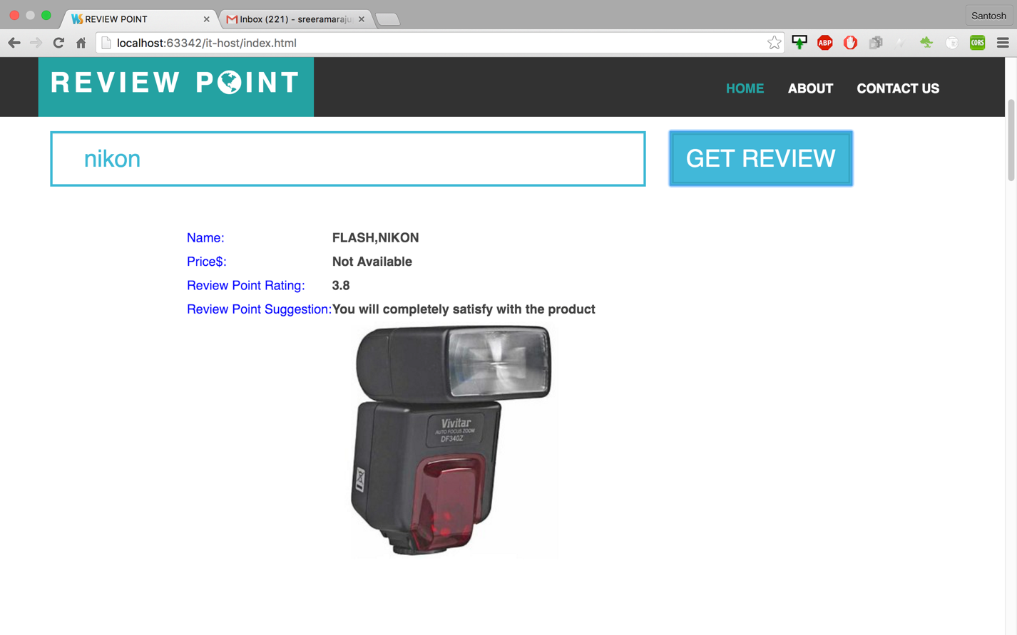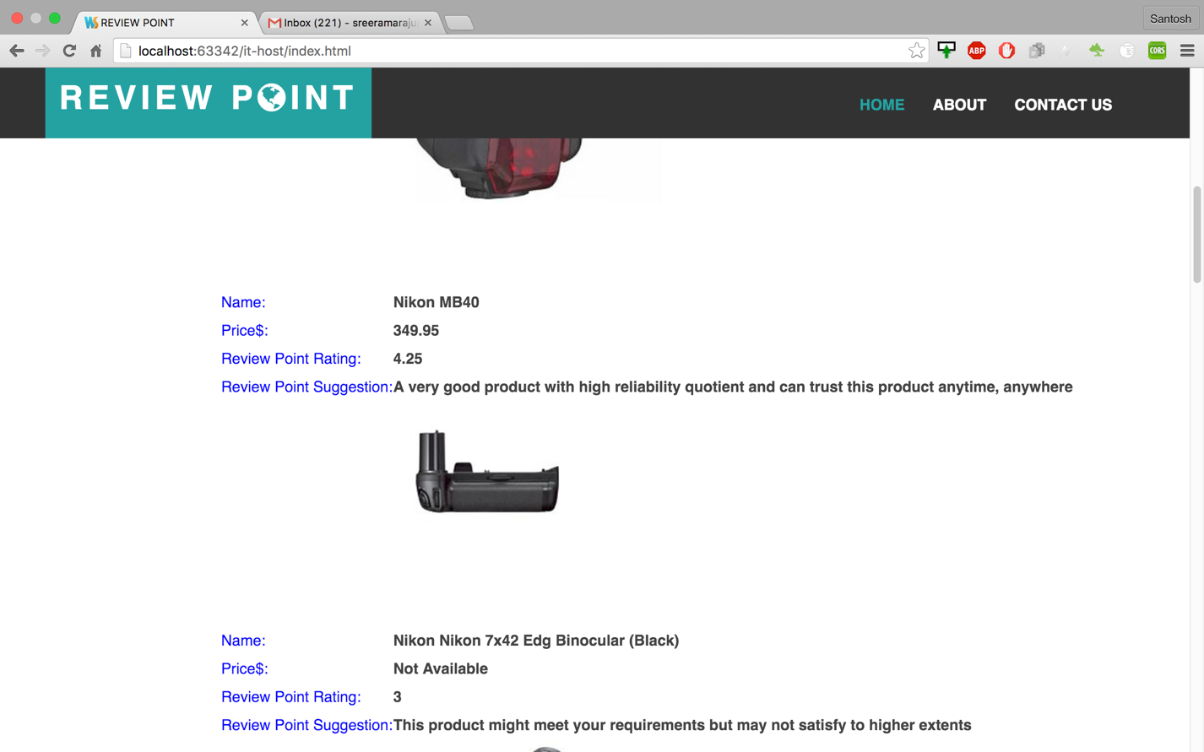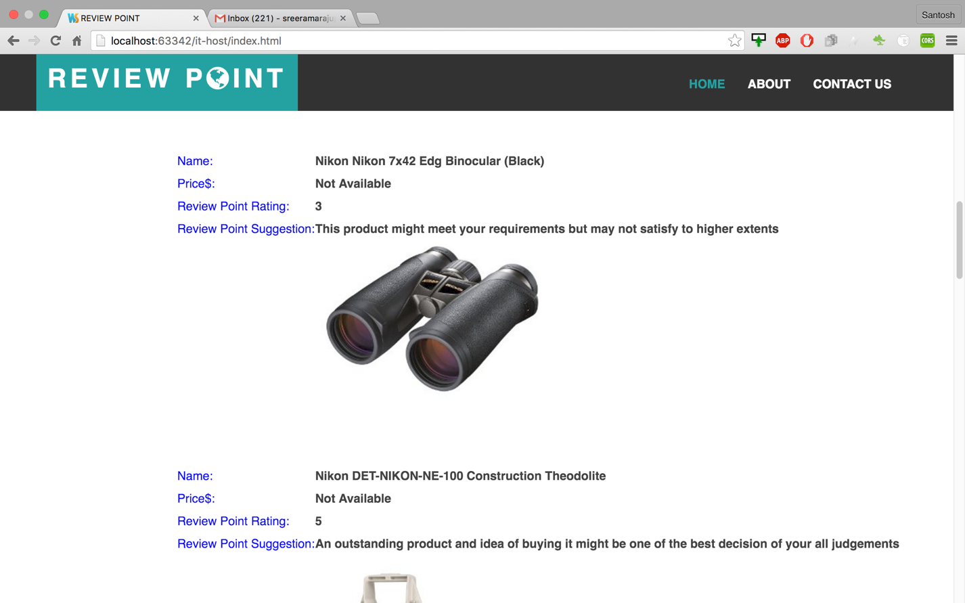

**Major outcomes of our application:**

1. **User should open our application Review Point**
2. **This application contains the Home, About and Contact Us pages**
3. **User should provide the product name and click on the Get Review Button in the Home page**
4. **Application displays the Image, Title, Price, our own rating and also provides the suggestions for that product.**
5. **We only analyze the top 10 ratings of any product and provides the details.**

**Github link:** [**https://github.com/sk559486/HackathonSpring16.git**](https://github.com/sk559486/HackathonSpring16.git)

**Power point presentation link:**

[**https://github.com/sk559486/HackathonSpring16.git**](https://github.com/sk559486/HackathonSpring16.git)

**YouTube video URL:** <https://youtu.be/VcYo5jNJ1Fc>